**Better Scientific Software (BSSw) Fellowship**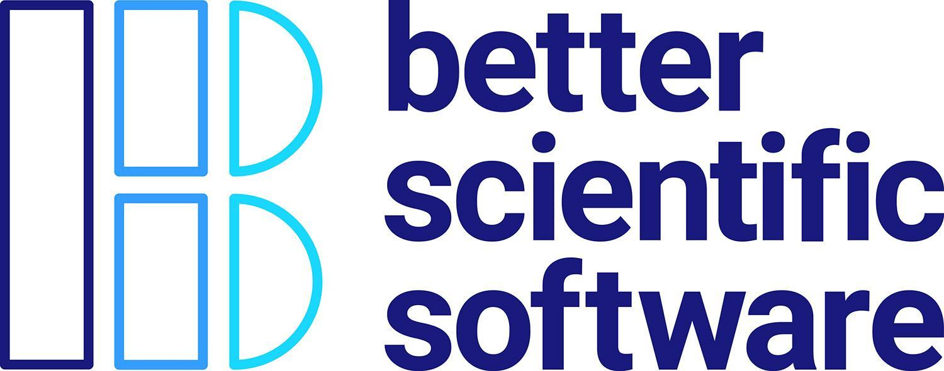

Statement of Work, Milestones and Guidelines *2021-2022 Period of Performance*

|  |  |
| --- | --- |
| **Personal Information** *(as it should appear on* [*https://bssw.io/pages/meet-our-fellows*](https://bssw.io/pages/meet-our-fellows)*)* | |
| **Name** | ***Amy Roberts*** |
| **Organization** | *CU Denver* |
| **Title, Dept** | *Assistant Professor, Department of Physics* |
| **LinkedIn** | *https://www.linkedin.com/in/amy-roberts-92061b90/* |
| **Github** | *@pibion* |
| **Other URLs** | *https://clas.ucdenver.edu/physics/amy-roberts-phd* |

|  |  |
| --- | --- |
| **Project Description** *(as it should appear on* [*https://bssw.io/pages/meet-our-fellows*](https://bssw.io/pages/meet-our-fellows)*)* | |
| **BSSw Focus Area(s)** | *Focus Area: Reliability; Subtopic: Reproducibility*  *Focus Area: Better Planning; Subtopic: Software Process Improvement*  *Focus Area: Better Development; Subtopic: Documentation*  *Focus Area: Better Development; Subtopic: Revision Control*  *Focus Area: Better Skills; Subtopic: Personal Productivity and Sustainability* |
| **IMPACT TAG-LINE**  *(short statement, see* [*https://bssw.io/pages/meet-our-fellows*](https://bssw.io/pages/meet-our-fellows) *for examples under each Fellow’s name, e.g. Jeff Carver - Improving code quality through modern peer code review)* | *Enabling collaborative work on scientific software through user-focused version control tutorials* |
| **ABSTRACT** *(paragraph, see* [*https://bssw.io/fellows/ignacio-laguna*](https://bssw.io/fellows/ignacio-laguna) *for example)* | *Amy is developing tutorials on version control that give scientists the information they need to contribute to shared software. Version control is an essential tool for collaborative work on software, but domain scientists lack the knowledge they need to contribute to these efforts. There are often only a handful of developers who have the skills needed to work collaboratively on software and this limits the sustainability of software efforts that are increasingly crucial to their communities. The version control tutorials will center around common user stories and directly address how a scientist should interact with version control to work collaboratively in common science scenarios. Art that illustrates broader ideas will be commissioned and tested along with the tutorials. All of the tutorial materials will be released with an open license to encourage the creation of high-quality resources that directly address common version-control situations researchers face.* |
| **BIO** *(paragraph, see* [*https://bssw.io/fellows/ignacio-laguna*](https://bssw.io/fellows/ignacio-laguna) *for example)* | *Amy is an assistant professor of physics at CU Denver. She searches for dark matter signals and works to build accessible computing ecosystems.* |

|  |  |
| --- | --- |
| **Project Plan & Milestones** | |
| **Detailed Approach**  *(based on original proposal)* | *I plan to improve functional knowledge of version control in the scientific community by making version control training materials that focus on user stories. I will (1) develop story-based, interactive lessons, (2) commission art that maps common version control situations onto everyday concepts, and (3) improve*  *these materials with group testing.* |
| **Contract Milestones:**  BSSw Fellowship funds will be disbursed in accordance with achieved milestones via a subcontract from the Krell Institute. Milestones should include some deliverable or evidence of completion and will be included in your Statement of Work. Refer to the examples below to help guide your specific milestone descriptions.   * **Milestone 1:** Written report with plan of record for content delivery to community and up-to-date progress. **Amount:** 25% of contract **Target deadline:** April 1, 2021 * **Milestone 2:** Delivery/presentation of content to community (e.g., conference, workshop, etc.) and in the form of an [HPC Best Practices webinar](http://ideas-productivity.org/events/hpc-best-practices-webinars).  **Amount:** 50% of contract **Target deadline:** December 1, 2021 * **Milestone 3:** Contribution to [BSSw.io](http://bssw.io) in the form of an authored blog or article based on your fellowship work. Use [Contribute to BSSw](https://bssw.io/pages/what-to-contribute-content-for-better-scientific-software) for content guidance. **Amount:** 25% of contract **Target deadline:** March 31, 2022 | |
| **Milestone 1** | *Written report with plan of record for content delivery to community and up-to-date progress. This plan will include: user stories, art identified, and licensing. This plan will also identify appropriate webinars for milestone 2, with the goal of discussing lessons learned in transferring theory to practice.*  *Amount: 40% of contract*  *Target deadline: May 1, 2021* |
| **Milestone 2** | *Delivery/presentation of content to community (e.g., conference, workshop, etc.) and in the form of an “HPC Best Practices” webinar.*  *Amount: 40% of contract*  *Target deadline: December 1, 2021* |
| **Milestone 3** | *Contribution to BSSw.io in the form of an authored blog or article based on your fellowship work. Use “Contribute to BSSw” for content guidance.*  *Amount: 20% of contract*  *Target deadline: March 31, 2022* |

|  |  |
| --- | --- |
| **Expectations & Guidelines** *Read the guidelines and expectations for being a BSSw Fellowship recipient.* | |
| **Acknowledge BSSw in Your Funded Work** | Please use the following acknowledgement in full: *This work was supported by the Better Scientific Software Fellowship, supported by the National Science Foundation under Grant No. (TBD).*  Except for articles or papers published in scientific, technical or professional journals, the following disclaimer must be included:  "Any opinions, findings, and conclusions or recommendations expressed in this material are those of the author(s) and do not necessarily reflect the views of the National Science Foundation." |
| **Seek Communications Approval** | Our sponsors must clear any communications/articles about the BSSw Fellowship that you or your home institution may want to publish: Please send a draft of any article to Hai Ah Nam (hnam@lanl.gov) prior to publication. We will then clear content with our sponsors to ensure that the article meets guidelines. |
| **Be Mindful of Logo Use** | Use of the [Better Scientific Software logo](https://drive.google.com/file/d/1sgGIwqgfMHjHOEvygWRSx1DPfVqIhBZc/view?usp=sharing) in conjunction with your fellowship activities is encouraged. Use of other logos (NSF, DOE, ECP, IDEAS Productivity project) is not appropriate for this work. |
| **Engage with Sponsor R&D Communities** | Attend the BSSw Fellowship Program annual meeting, currently co-located at the Exascale Computing Project annual meeting. Continue to engage with the DOE and NSF community throughout your fellowship term. |
| **Additional Policies** | Adhere to NSF Proposal & Award Policies & Procedures Guide ([NSF-20-1](https://www.nsf.gov/pubs/policydocs/pappg20_1/index.jsp)) |